Detecting COVID-19 in Chest X-rays Using Deep Learning

# Introduction

Before we talk we Deep Learning let’s start with AI. So AI is a field in computer science that focuses on the creation of intelligent programs and machines. I believe you’re probably familiar with self-driving cars, recommender systems, speech recognition. So Deep Learning is field in ai that uses a concept we refer to DNN, which are basically mathematical functions when trained e.g on images can make predictions on new images from the same domain.

COVID-19 is a communicable respiratory disease caused by the SARS-CoV-2 commonly know as the coronavirus. COVID-19 looks very similar to other viral and bacterial pneumonias which results in inflammation and fluid in the lungs, on chest radiographs or x-rays,  which makes it difficult to diagnose. DL application in Computer Vision or Image Recognition can be applied to help doctors diagnosis.

# Problem

On average it takes 5 minutes to collect a single sample, and about few hours or even a day to get back results as molecular tests take time. This project is meant to help reduce this diagnosis time to under half-an hour since it takes about 15 minutes to perform an x-ray and a few seconds for a trained model to make a prediction.

# Proposed Solution Data Flow Diagram

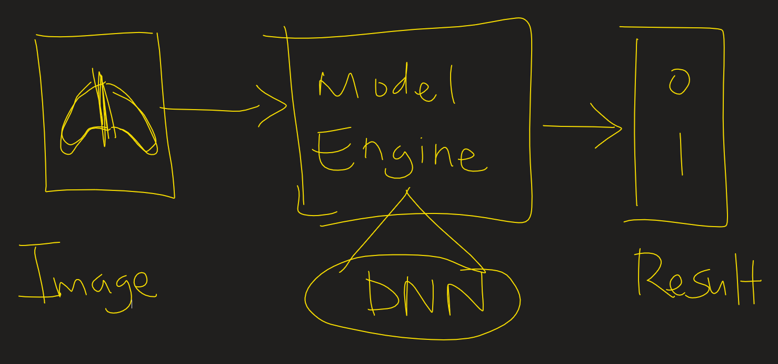

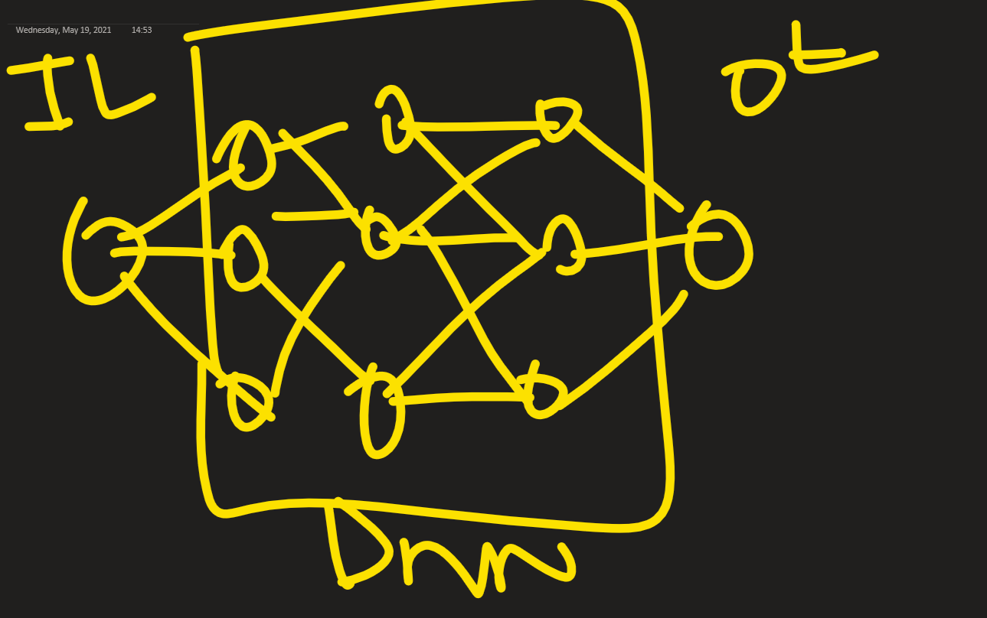

# Cost Benefit Analysis

## Cost

* Costs for a single X-ray scan for uncovered persons can be about $370 which is not favorable to all.
* Procurement of sufficient X-rays Scanners may expensive for health institutions unless the government subsidies costs.

## Benefits

* Reduced costs for covered persons. It costs $60 to $100 to get tested for COVID-19 as no insurance can be used.

With X-rays, insurance can be used.

* Reduced diagnosis time
* Easier administering of vaccines due to possible reduced result release time
* Potentiality to reduce costs for health institutions as since procurement of testing kits may no longer be necessary